U. S. Complete Shooting Dog Amateur Invitational
by Art Mourino

On December 2-3, 2016, the twelfth annual U. S. Complete National Amateur Invitational was held. Judges Bruce Conover and Don Augustine named Hard Tellin an 8 year old pointer female the champion. Hard Tellin is owned and handled by Dave O’ Brian. Rutter’s Dusty Socks, a 5 year old male setter owned and handled by Phil Rutter from Marshall, VA was named the Runner-up Champion. Dusty’s sire is That’s A Fact Jack.

Bruce Conover, a judge, is an avid hunter and gundog enthusiast. Bruce has competed in pointing dog field trials and other formal pointing dog competitions for more than 30 years. He has personally trained and has campaigned more than 10 field trial dogs over the years. He has accumulated 15 open and amateur championships under both the American Kennel Club and the American Field banners since 1995. He currently campaigns Brittany’s and a Pointer in both AKC all-breed and American Field competitions. His judging record spans over 22 years and includes more than 125 judging assignments at the regional and national levels. He judged the American Brittany National Amateur Championship three times, the 2015 U.S Complete Amateur Championship, and the 2016 Vizsla National Amateur Shooting Dog Championship.

Don Augustine grew up in Western New York with some of the best Pheasant and Grouse hunting in the mid sixty’s. In the late seventies he trained his own dogs for competitive trials. His field trial champions include Hi-Tail’s K-C Gun Smoke, Hi- Tail’s Jess, Hi-Tail’s Kickin’it Up, Hi-Tail’s Shadow man, Hi-Tail’s Archibald, Hi-Tails Easy Rider, and is currently campaigning Hi-Tails All Wound Up. He has run his dogs in AKC and American Field. He has run his dogs in horseback All Age and Gun Dog for over 40 years with his wife Marilyn, daughter, and sons. In the mid seventy’s he formed the Niagara Brittany Club in Western New York and held positions as president as well as the Southeastern Brittany and Tar Heel Brittany club in North Carolina where he currently resides. He has also held positions as secretary, treasurer, and director in all three clubs. He has competed and judged trials in New York, Pennsylvania, Ohio, Virginia, Michigan, Illinois, Indiana, and Maryland.

For the ninth year Art Mourino was the chairperson. Art put together a committee that saw that no stone was left unturned and no detail was left out in order to make this a tremendous event. Art caught the birds with the help of Jamison Crandall. Jamison planted birds for almost every brace.
Kirk Regensburg drove Mert Jones’ John Deere tractor which was pulling a gallery wagon for viewing the contestants. Photo coverage and information about each dogs run was handled by Phil Townley.

Purina as always generously supplied dog food for all of the participants. Purina provided 1 bag of Purina Pro Plan Performance to all 14 participants and the 2 judges. They also provided 12 bags of Purina Pro Plan Performance to the Champion and 6 bags to the runner up. Garmin provided a Pro 550 collar to the Champion. The Association is greatly appreciative of Purina’s and Garmin’s support, not only for this championship but for all the U.S. Complete trials they support.

In addition the Champion was awarded the U. S. Complete National Amateur
Invitational Championship revolving trophy. This beautiful trophy was donated
Dr. Aubrey Morgan and Gary Ansell, and features a pair of stuffed quail enclosed in glass on a wooden pedestal base.

WINNERS DAY 1

On day 1 Dave O’Brien’s Hard Tellin a pointer female ran in the second brace with Verlene Stephenson’s Shadow’s Carolina Molly, a pointer female. Hard Tellin put down a strong forward stylish race and was found to the front on point with excellent style and intensity at 14 in the stripped wooded area. At 20 Hard Tellin had a find over the top of the hill at the first Kettle Creek Crossing. At 27 Shadow’s Carolina Molly was found standing just below the big oak tree. At 29 Hard Tellin found a bird in the woods to the right of the path before the second Kettle Creek crossing and all was in order. At 35 at the triangle Hard Tellin was standing with Molly backing. Every thing was in order. At 42 Hard Tellin was found standing after the triangle area. After exhausting attempts to flush were unproductive, the handler took his dog on up the course. At 50 Shadow’s Carolina Molly was found standing a bird in the long field after the Cabin, Hard Tellin was found “honoring“ her brace mate. All was in order for both dogs to the wing and shot and both dogs were sent on. Both dogs finished in the break away field. 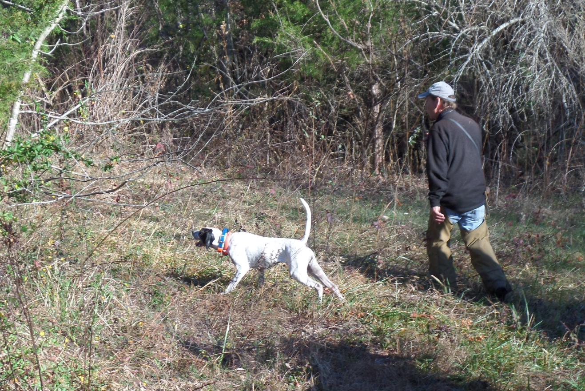.

Dave O’Brien is going to flush a bird with Hard Tellin on point.

Phil Rutter’s Dusty Socks, a setter male ran in the fourth brace with Bob’s Elhew Jill, a pointer female. At 3 minutes Jill could be seen standing a bird across the field near the strip before the road. It was @ 6 ½ minutes before the handler could arrive and flush the bird. At 13 minutes, Jill was found standing in the striped area across the road. Jill was relocated at 15 and 17 and she was sent on when no bird could be produced. At 19 Dusty was looking very good on a classic style point just past the first Kettle Creek crossing. All was in order to the wing and shot. At 21, Jill was standing a bird on the hill just pass the 1st Kettle Creek crossing but lost some of her manners and put the bird up. At 28 Jill’s handler decided to pick Jill up after another bird was put up. At 29 Dusty had his bird pointed in the area of the triangle and all was in order. Dusty was sent on and he was the most forward running dog so far this day. Dusty finished in the breakaway field pass the pond.

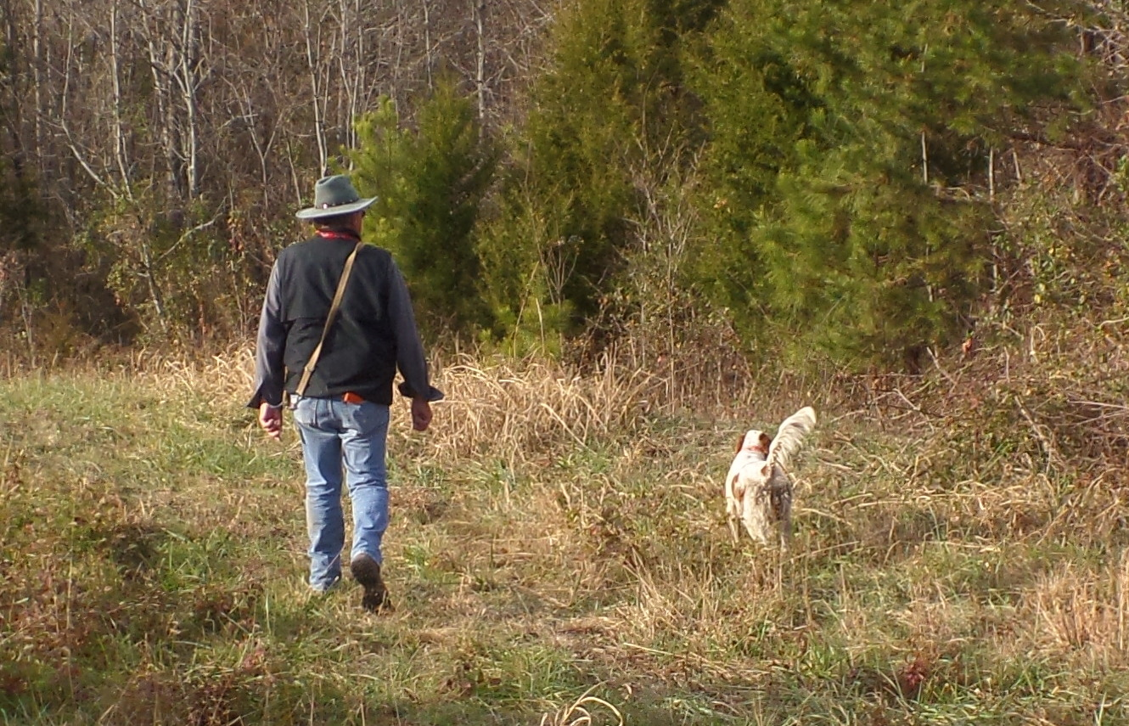

Phil Rutter is going to flush a bird at the end of the second day’s trial.

WINNERS DAY 2

On day 2 Hard Tellin was braced in the fourth brace with the Outsider. At 8 minutes both dogs were found standing at the beginning of the river bottom just to the left of the path. Quail could be seen in front of both dogs. The Outsider could not handle the excitement and broke at the flush and shot. Hard Tellin stayed steady through out the flush and shot, even after the other dog broke point. The Outsider was picked up and Hard Tellin was sent on. At 23 Hard Tellin was found standing a bird at the end of the river bottom with all in order. At 49 Hard Tellin was found standing in the field at the top of the hill and she was steady again to both flush and shot.

At 7 minutes both Dusty and the Islander were found pointing at the beginning of the river bottom. A quail was spotted just in front of Dusty and Dusty’s handler moved in to make the flush with both handlers discharging their guns for a divided find. Both dogs were steady to the wing and shot. At 21 both dogs were found with Dusty honoring Islander’s point. After attempts to flush the bird, Dusty’s handler received permission to take his dog on. At 25 Islander was allowed to relocate and the bird was produced. The Islander was steady to wing and shot. At 46 Dusty was found standing in the field at the top of the hill next to the road, near a small clump of under brush. The Islander was honoring Dusty’s point. Dusty’s handler was having difficulty finding the bird and the Islander’s handler received permission to take his dog on up the course. Dusty was allowed to relocate but a bird could not be produced. At 53 Dusty went on point in the back of the hill top field, very staunch with a classic point. He was steady to wing and shot and sent on to finish the course.

The Running

Day One: A cool day starting out in the low 30’s, heavy frost, little to light wind, perfect for running dogs. The upper course was used on Friday and the River Bottom course on Saturday. We were fortunate to be able to use the River Bottom due to a lack of rain. The Friends of Dick Cross, composed of local Field trailers used a lot of man power to open the thick cover that grows rampant on both courses. Work days are also scheduled to clean the clubhouse, the horse barns, cut grass and the cleaning of 80 dog pens. All clubs that use the facilities also send a check for each day they have a trial to The Friends of Dick Cross to support these activities. On day one the dogs broke away in the big field by the club house heading to the left before they cross a path. The dogs had to take a quick left and travel up and around the small islands of pine trees. They had to go up a hill to cross the first Kettle Creek crossing. This led to open fields and passing the old oak tree and cross the Kettle Creek again returning into an open field to the triangle and going up a hill to the Cabin returning into an open field and back to the starting line.

The majority of this year’s 14 contenders gave the judges something to look at and a lot to choose from. It was sunny and clear for the first brace with temperatures rising to low 50's in the afternoon. Day 1 was run on the upper course. Judges this year were Bruce Conover from South Boston, VA and Don Augustine from Macclesfield, NC. We want to thank Phil Townley who took pictures this year and did the write up of each brace.

The weather conditions were great and every dog had opportunities to point and back.

Brace 1:
First Brace was the Outsider, setter female owned and handled by Art Mourino braced with the Islander owned and handled by Pete Kazic. At 15 minutes the Islander was found standing across the road in the stripped area. At 19 a bird was produced. The Outsider was steady to honor the Islander’s point. At 24 the Islander was found over the hill past the first Kettle Creek crossing, a bird was produced, all was in order. However the Outsider had a lapse of manners and failed to honor her brace mate’s point. At 32 the Islander had a bird just pass the old oak tree and all was in order. At 42 the Outsider had her bird nailed in the triangle area and was staunch. However, the Islander had a lapse of manners and failed to back his brace mate’s point by standing next to her. At 52 the Islander was found standing in the long field after the cabin, all was in order. The Outsider remembered her manners and “backed” the Islander at a fair distance
Brace 2:
Hard Tellin, pointer female owned and handled by Dave O’brien’s and Shadow’s Carolina Molly, owned and handled by Verlaine Stephenson. (See Winners Day 1)

Brace 3:

Third brace was Vitale’s Grouse Ringer Razzle, setter male owned and handled by Gary Vitale and Braeval’s Bearcat Laddie, Irish setter male handled by Gregor McCluskey. At five minutes Laddie locked up very staunch in the field near the strip before the road and was a beauty to behold, however the excitement was too much for his brace mate Razzle who took out the bird. Laddie held until released by his handler and both dogs went on. At 13 Laddie was found standing a bird in the striped area across the road; however his brace mate, Razzle had another lapse of manners and put the bird up. Laddie held until released by his handler and both dogs went on. At 19 Laddie was standing a bird just over the hill from the first Kettle Creek crossing, and all was in order. At 24 Razzzle found a bird in the area just pass the big Oak tree. This time he was holding tight for the wing and shot. At 32 Laddie had a fine at the chute leaving the triangle with Razzle backing. At 45 Laddie had a fine at the long field after the cabin. All was good to the wing and shot.

Brace 4:

Phil Rutter’s Dusty Socks, a setter male owned by Phil Rutter and Bob’s Elhew Jill, a pointer female owned and handled by Bob Phillips. (See Winners Day 1)

Brace 5
The fifth brace was Daddy’s Little Boy Butch, pointer male owned and handled by Paul Scott braced with Grouse Hill Belle, pointer female, owned and handled by John Capocci. At 8 minutes both dogs were found in the strip before crossing the road, Butch was standing the bird and his brace mate Belle was honoring. All was in order and they were sent on. At 18 Belle was found on point with a bird in the stripped area after crossing the road and all was in order. Butch at 29 was pointing in the area below the big Oak tree, when the bird got up, Butch turned to watch it go, but was steady to the shot. At 36 near the end of the triangle area Butch found another bird and all was in order. At 49 in the long field past the cabin, Butch was found standing a bird and he was steady to wing and shot. Both dogs finished in the break away field.
Brace 6
The sixth brace was Bob’s Elhew Holly, pointer female owned and handled by Bob Phillips and braced with Haywood’s Cindy, pointer female owned and handled by Butch Haywood. At 3 Holly was standing in the field next to the strip before crossing the road. Cindy was observed coming into the field when Cindy saw Holly pointing she honored from a great distance. It was estimated that she had backed from 100-200 yards away. Several people in the gallery were excited to see a dog back from such a distance. Holly was found standing a bird in the stripped area across the road and all was in order. At 26 Cindy was found standing just below the big oak tree but after an exhaustive search and relocating no bird could be found. At 32 Holly was found in the triangle area standing a bird, her brace mate Cindy was backing. On the flush Holly moved her feet to watch the bird but was steady to the shot. At 40 Cindy was found standing a bird in the chute after leaving the triangle area. She was relocated once and a bird was produced and all was in order. At 48 Cindy was found standing in the long field past the cabin. A bird was produced all in order. At 51 Holly found a bird at the beginning of the chute going to the finishing field. Cindy backed Holly and both dogs were steady to the flush but Cindy was excited and broke at the shot. Both dogs finished in the breakaway field.

Brace 7

The seventh brace was Backcountry Polly, a pointer female owned and handled by Chris Catanzarite braced with Little River Blue Ice a pointer female owned and handled by Mert Jones. At 22 minutes Polly was found on point as you come into the power line field, on the left in an autumn olive thicket. Polly was relocated and went even deeper into the thicket. Chris was able to produce a bird at 25. Polly was good to the wing and shot. Little River Blue Ice did not produce a point but ran a very forward race. Both dogs finished in the break away field.

Day 2

The morning of the second day started off in the low 30’s with some clouds around mid morning and a breeze picked up mid morning through the afternoon. The River Bottom Course was used. We had two scratches so we ran only 6 braces.

Brace 1

The first brace of the day was Haywood’s Cindy, pointer female handled by Butch Haywood and Backcountry Polly, pointer female owned by Chris Catanzarite. At 16 minutes Cindy was standing about half way in the river bottom, her brace mate honored her point but her tail was ticking. Cindy self relocated when the handler attempted a flush. A bird was never produced. Cindy’s handler picked her up at 21. At 38 Polly was found standing in the bottom below the silo in the edge of the woods, after an exhaustive search and relocation a bird was not found. Chris took his dog up the course and at 48 Polly was found standing a bird in the field at the top of the hill next to the road. Polly was steady to wing and shot.

Brace 2

In the second brace were Little River Blue Ice, pointer female handled by Mert Jones and Grouse Hill Belle, pointer female handled by John Capocci. At 7 minutes Belle was found standing at the beginning of the river bottom and was steady to wing and shot. At 18 in the mid section of the river bottom Belle was found standing a bird and all was in order. At 25 Belle was found standing near the end of the river bottom course and she held tight for the wing and shot. At 30 Belle went on point below the dam, she was steady with her tail ticking. At 38 Belle was standing below the silo in a thicket. She was steady. At 51 in the field at the top of the hill next to the road, Belle had a lapse of manners and put the bird in the air. Little River Blue Ice finished the course with no bird work but again with a forward race.

Brace 3

In the third brace were Vitale’s Grouse Ringer Razzle, setter male handled by Gary Vitale and Daddy’s little Boy Butch, handled by Paul Scott. At 26 minutes both dogs were found standing, side by side with Razzle slightly ahead of Butch, at the end of the river bottom course. Razzle’s handler moved in to flush but it was more than Butch could take and broke at the flush. Razzle was steady to the wing and shot. Butch was taken up. At 54 Razzle was found standing in the field at the top of the hill next to the road, the quail was spotted sitting off the ground in a small tree. Razzle was steady to the flush and shot and was sent on to finish the course.

Brace 4:
Hard Tellin, pointer female, Dave O’Brien and The Outsider, setter female
(See Winners Day 2)

Brace 5:
The fifth brace was Braeval’s Bearcat Laddie, Irish setter male, Gregor McCluskey and Shadow’s Carolina Molly, Verlene Stephenson. At 7 minutes Laddie was found standing at the beginning of the river bottom, staunch on point, steady to wing and shot. At 12 Laddie went on point about mid way in the river bottom slightly to the left of the path. He was allowed to relocate @15 but a bird could not be produced. At 22 Laddie went on point near the end of the river bottom. Unfortunately, Laddie decided to relocate himself just as his handler got near. No bird was produced and Gregor picked up his dog. At 34 Molly decided she would go for a swim in the marsh in the middle of the dam area. Molly would not listen to the scout. Verlene decided Molly needed to help her dog out of her predicament.

Brace 6
Rutter’s Dusty Socks, setter male, Phil Rutter
Islander, setter male, Pete Kazic
(See Winners Day 2)

I would like to thank all of the participants who had to travel to the championship and I hope they enjoyed themselves.

Some Sidelights:

Verlene Stephenson sold raffle tickets to help support this event. Items were mainly provided by the participants and I would like to thank those who brought items and those who purchased raffle tickets. The raffle had many practical as well as humorous items. U.S. Complete national Treasurer, Mert Jones, was on hand to handle paperwork and take entry fees. Phil Townley took a group photo of all the participants. Phil Townley took photos of each brace along with write ups of the dogs. Photos and brace write-ups can be viewed on the website at www.uscomplete.org. Phil also conferred with the judges each day to compile the comments posted. Judy Jones and Sharon Townley handled kitchen duties and provided lunches and dinner. The social hour consisting of shrimp, cheese, vegetable and fruit trays was provided by the owner and handler of last year’s winner Phil Rutter. Also provided were marmalade meatballs, teriyaki wings and a Mexican dip. Friday for lunch Judy Jones made her famous chicken casserole and green beans. Dinner consisted of smoked pork loin, mash potatoes, green beans and banana pudding for desert. Saturday, for lunch home made turkey noodle soup, fresh ham biscuits, left over platters and pumpkin crunch bars.

The grounds at Dick Cross WMA were well groomed. Major removal of brush allowed the opening of the grounds. We would like to thank Pat Casey, Ivan Clark, Hans Borgman, George Doyle, Bruce Conover, Pat Casey and the Friends of Dick Cross for cutting the areas on both courses. The Friends of Dick Cross also cleaned the club house, the horse stalls and dog kennels in the summer.

David O’Brien, CH Hard Tellin being held by George Doyle the Champion and Phil Rutter with RU Rutter’s DustySocks, Runner-UP With Sharon Townley

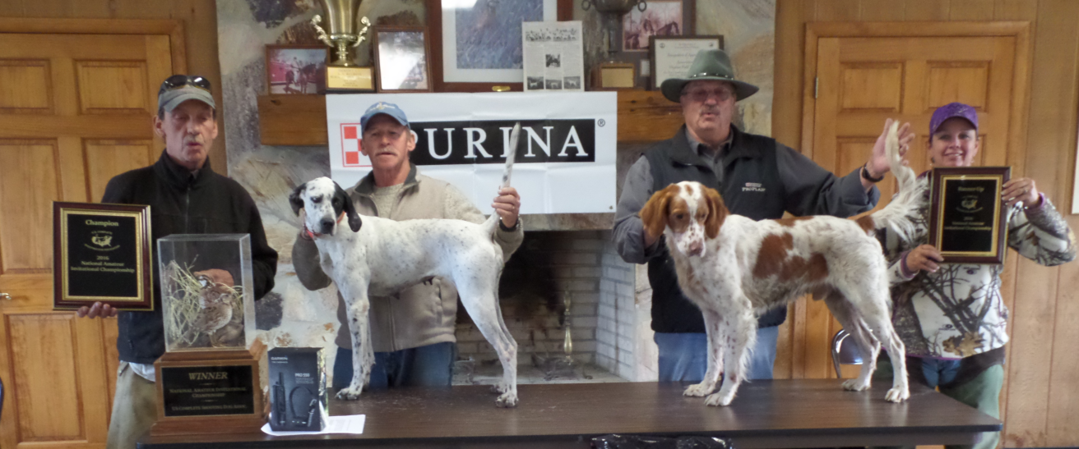

Back Row from left to right: Hard Tellin with Dave O’Brien, Grouse Hill Belle with John Capocci, Vitale’s Grouse Ringer Razzle with Gary Vitale, Rutter’s
Dusty Socks with Phil Rutter, Haywood’s Cindy with Butch Haywood, Braeval’s Bearcat Laddie Irish with Gregor McCluskey, Daddy’s Little Boy Butch with Paul Scott, Bob’s Elhew Jill with Morgan Fraczkowski
Kneeling: Shadow’s Carolina Molly with Verlene Stephenson, Islander with Pete Kazic, Little River Blue Ice with Mert Jones, Backcountry Polly with Chris Catanzarite, The Outsider with Art Mourino, and Bob’s Holly with Bob Phillips.

